|  |
| --- |
| **Unsupervised Learning in a Biologically Plausible Model of Homeostasis and STDP** |

**Colleen P. Chen**

Department of Cognitive Science

University of California, Irvine

Irvine, CA

[*colleepc@uci.edu*](mailto:colleepc@uci.edu)

**Abstract**

……...

**1 Introduction**

Biological neurons use sudden increases in voltage to transmit information. These signals are more commonly known as action potentials, or spikes. Neurons encode information in the timing of single spikes, in addition to their average firing rate. The learning process in the brain can be thought of as the change of synaptic strength over time; this ability is known as synaptic plasticity. Networks of spiking neurons can encode temporal information in their signals, and therefore require biologically plausible rules for synaptic plasticity.

Figure 1. Homeostatic synaptic plasticity. (A) The maintenance of a constant baseline-firing rate given perturbed spikes in either direction using homeostatic regulation of synaptic properties. (B) firing rate homeostasis achieved through synaptic scaling. Given perturbed activity, synaptic scaling produces a proportional reduction or increase in magnitude of synaptic strength to return firing to baseline levels. Because this mechanism scales synaptic strength up or down proportionally, the relative difference in synaptic strengths induced by Hebbian mechanisms is preserved. Recreated from [1].

**1.1 Spike-timing dependent plasticity**

Spike-timing dependent plasticity (STDP) is a learning rule that takes the form of Hebbian learning but with strict time dependencies. Hebbian learning between pairs of neurons strengthens a synapse when the neurons spike around the same time, not account for temporal order. STDP, on the other hand, strengthens a synapse when the presynaptic neuron fires before the postsynaptic neuron, in expected causal order, otherwise the synapse is weakened; as such, it is a timing order dependent specialization of Hebbian learning. STDP explains how the temporal difference between a pre-and postsynaptic spike affects the amount of synaptic potentiation or depression. Long-term potentiation (LTP) is measured by the amplitude of the excitatory postsynaptic potential (EPSP) of the neuron, which correlates with the amount of current that is imparted into postsynaptic neuron by presynaptic neuron. An increase in EPSP means that each presynaptic spike is imparting more current to the postsynaptic neuron and has more influence on whether the postsynaptic neuron fires. Long-term depression (LTD) is the depression mechanism that works opposite LTP. While LTP causes increases in synaptic strength that persist over days and months, LTD causes decreases in synaptic strength that persist on the same time scale. This project presents a computational model of a spiking neuron that has synapses, which are plastic and dependent on spike times.

**1.2 Homeostatic Synaptic Scaling**

An important observation from computational models of spiking networks using STDP rule is that it is unstable. Stability, when discussing learning rules, means that the learning rule will result in a constant distribution of synaptic strengths for synapses attached to a neuron. If the synapses are only potentiated, then all of the synapses will reach some maximum strength, or as seen in computational models, go to infinity. If the synapses are only depressed or weakened, then all of the synapses will reach some minimum strength or go to negative infinity. In the current proposed spiking network model, this instability leads to runaway synaptic potentiation. Runaway synaptic dynamics occurs when a presynaptic neuron consistently excites a postsynaptic neuron to fire, increasing the synaptic strength at every subsequent pairing. This increase in synaptic strength causes the postsynaptic neuron to fire more rapidly, strengthening additional synapses and eventually resulting in a boundless increase of all presynaptic connections to the postsynaptic neuron. The excitatory synapses create a positive feedback loop that requires stability constraints to be imposed upon the computational model of system.

Homeostatic synaptic scaling imposes such stability constraint on the computational model of spiking network and act to stabilize neuronal activity. Homeostatic mechanisms such as synaptic scaling avoids runaway potentiation by allowing neurons to detect changes in their own firing rates and regulate weights to prevent runaway increases or decreases in synaptic strength, as illustrated in Figure 1. Global synaptic scaling preserves the relative differences in strength between synapses on a particular neuron. Multiplicative synaptic plasticity scales the weights in proportion to the difference between a time-averaged postsynaptic activity signal and a target postsynaptic activity signal. The homeostatic update rule adjusts the synaptic weights multiplicatively and depends on both the average firing rate of the neuron and some target firing rate.

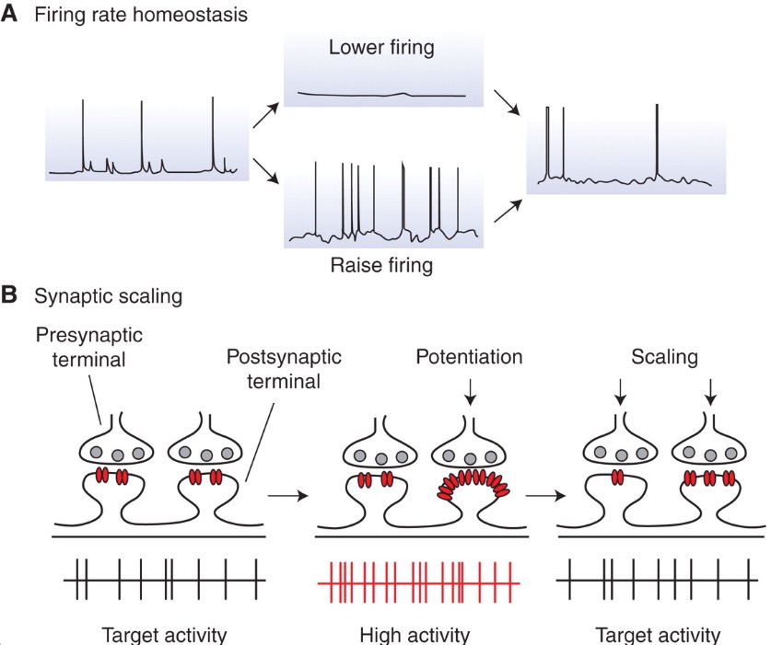

Figure 1. Homeostatic synaptic plasticity. (A) The maintenance of a constant baseline-firing rate given perturbed spikes in either direction using homeostatic regulation of synaptic properties. (B) firing rate homeostasis achieved through synaptic scaling. Given perturbed activity, synaptic scaling produces a proportional reduction or increase in magnitude of synaptic strength to return firing to baseline levels. Because this mechanism scales synaptic strength up or down proportionally, the relative difference in synaptic strengths induced by Hebbian mechanisms is preserved. Recreated from [1].

**1.3 Nonnegative Matrix Factorization**

Carlson et. al. proposed in [2] a biologically plausible mathematical description of a homeostatic synaptic scaling mechanism that prevents runaway synaptic dynamics, in this replication study, a computational model is implemented to examine the synapses simulated in the network and the firing behavior of the neuron.

**2 Methods**

The text must be confined within a rectangle 5.5 inches (33 picas) wide and 9 inches (54 picas) long.

**3 Ramp Simulation**

First level headings are lower case (except for first word and proper nouns), flush left, bold and in point size 12. One line space before the first level heading and ½ line space after the first level heading.

**3.1 MATLAB Implementation**

Second level headings are lower case (except for first word and proper nouns), flush left, bold and in point size 10. One line space before the second level heading and ½ line space after the second level heading.

**3.1.1 Brian simulator implementation**

Third level headings are lower case (except for first word and proper nouns), flush left, bold and in point size 10. One line space before the third level heading and ½ line space after the third level heading.

**4 Results**

These instructions apply to everyone, regardless of the formatter being used.

**4.1 Citations within the text**

Citations within the text should be numbered consecutively. The corresponding number is to appear enclosed in square brackets, such as [1] or [2]-[5]. The corresponding references are to be listed in the same order at the end of the paper, in the **References** section. (Note: the standard BibTeX style unsrt produces this.) As to the format of the references themselves, any standard reference style is acceptable, as long as it is used consistently.

As submission is double blind, refer to your own published work in the third person. That is, use "In the previous work of Jones et al. [4]", not "In our previous work [4]". If you cite your other papers that are not widely available (e.g. a journal paper under review), use anonymous author names in the citation, e.g. an author of the form "A.Anonymous".

**4.2 Footnotes**

Indicate footnotes with a number in the text. Place the footnotes at the bottom of the page on which they appear. Precede the footnote with a horizontal rule of 2 inches (12 picas).

**4.3 Figures**

All artwork must be neat, clean, and legible. Lines should be dark enough for purposes of reproduction; artwork should not be hand drawn. The figure number and caption always appear after the figure. Place one line space before the figure caption, and one line space after the figure. The figure caption is lower case (except for first word and proper nouns); figures are numbered consecutively.

Make sure the figure caption does not get separated from the figure. Leave sufficient space to avoid splitting the figure and figure caption.

You may use color figures. However, it is best for the figure captions and the paper body to make sense if the paper is printed either in black/white or in color.

|  |
| --- |
|  |

Figure 1: Sample Figure Caption

**4.4 Tables**

All tables must be centered, neat, clean and legible. Do not use hand drawn tables. The table number and title always appear before the table. See Table 1.

Place one line space before the table title, one line space after the table title, and one line space after the table. The table title must be lower case (except for first word and proper nouns); tables are numbered consecutively.

Table 1: Sample table title

|  |  |
| --- | --- |
| **Part**  **Description** |  |
| Dendrite | Input terminal |
| Axon | Output terminal |
| Soma | Cell Body (contains cell nucleus) |

**5 Final instructions**

Do not change any aspects of the formatting parameters in the style files. In particular, do not modify the width or length of the rectangle that the text should fit into, and do not change font sizes (except perhaps in the **References** section; see below). Please note that pages should be numbered.

**6 Preparing PostScript or PDF files**

Please prepare PostScript or PDF files with paper size “US Letter,” and not, for example, “A4.” The -t letter option on dvips will produce US Letter files.

Fonts were the main cause of problems in the past years. Your PDF file must only contain Type 1 or Embedded TrueType fonts. Here are a few instructions to achieve this.

* You can check which fonts a PDF files uses. In Acrobat Reader, select menu Files>Document Properties>Fonts and select Show All Fonts. You can also use the program pdffonts which comes with xpdf and is available out-of-the-box on most Linux machines.
* The IEEE has recommendations for generating PDF files whose fonts are also acceptable for NIPS. Please see http://www.emfield.org/icuwb2010/downloads/IEEE-PDF-SpecV32.pdf
* LaTeX users:
  + Consider directly generating PDF files using pdflatex (especially if you are a MiKTeX user). PDF figures must be substituted for EPS figures, however.
  + Otherwise, please generate your PostScript and PDF files with the following commands:
  + dvips mypaper.dvi -t letter -Ppdf -G0 -o mypaper.ps
  + ps2pdf mypaper.ps mypaper.pdf
  + Check that the PDF files only contains Type 1 fonts.
* xfig “patterned” shapes are implemented with bitmap fonts. Use “solid” shapes instead.
* The \bbold package almost always uses bitmap fonts. You can try the equivalent AMS Fonts with command
  + \usepackage[psamsfonts]{amssymb}
  + or use the following workaround for reals, natural and complex:
  + \newcommand{\RR}{I\!\!R} %real numbers
  + \newcommand{\Nat}{I\!\!N} %natural numbers
  + \newcommand{\CC}{I\!\!\!\!C} %complex numbers
* Sometimes the problematic fonts are used in figures included in LaTeX files. The ghostscript program eps2eps is the simplest way to clean such figures. For black and white figures, slightly better results can be achieved with program potrace.
* MSWord 2007 and Windows users (via PDF file):
  + Install the Microsoft Save as PDF Office 2007 Add-in from
  + http://www.microsoft.com/downloads/details.aspx?displaylang=en&familyid=4d951911-3e7e-4ae6-b059-a2e79ed87041
  + Select "Save or Publish to PDF" from the Office or File menu
* MSWord and Mac OS X users (via PDF file):
  + From the print menu, click the PDF drop-down box, and select "Save as PDF…"
* MSWord and Windows users (via PS file):
  + To create a new printer on your computer, install the AdobePS printer driver and the Adobe PostScript Printer Description (PPD) file from
  + <http://www.adobe.com/support/downloads/detail.jsp?ftpID=204>
  + *Note:* You must reboot your PC after installing the AdobePS driver for it to take effect.
  + To produce the ps file, select "Print" from the MS app, choose the installed AdobePS printer, click on "Properties", click on "Advanced."
  + Set “TrueType Font” to be “Download as Softfont”
  + Open the “PostScript Options” folder
  + Select “PostScript Output Option” to be “Optimize for Portability”
  + Select “TrueType Font Download Option” to be “Outline”
  + Select “Send PostScript Error Handler” to be “No”
  + Click “OK” three times, print your file.
  + Now, use Adobe Acrobat Distiller or ps2pdf to create a PDF file from the PS file. In Acrobat, check the option “Embed all fonts” if applicable.

If your file contains Type 3 fonts or non embedded TrueType fonts, we will ask you to fix it.

**6.1 Margins in LaTeX**

Most of the margin problems come from figures positioned by hand using \special or other commands. We suggest using the command \includegraphics from the graphicx package. Always specify the figure width as a multiple of the line width as in the example below

\usepackage[dvips]{graphicx} ...

\includegraphics[width=0.8\linewidth]{myfile.eps}

or

\usepackage[pdftex]{graphicx} ...

\includegraphics[width=0.8\linewidth]{myfile.pdf}

for .pdf graphics. See section 4.4 in the graphics bundle documentation (http://www.ctan.org/texarchive/macros/latex/required/graphics/grfguide.ps)

A number of width problems arise when LaTeX cannot properly hyphenate a line. Please give LaTeX hyphenation hints using the \- command.

**Acknowledgments**

Use unnumbered third level headings for the acknowledgments. All acknowledgements go at the end of the paper. Do not include acknowledgements in the anonymized submission, only in the final paper.

**References**

1. G. Turrigiano, “Homeostatic Synaptic Plasticity: Local and Global Mechanisms for Stabilizing Neuronal Function,” Cold Spring Harb. PErspect. Biol., vol. 4, no. 1, Jan. 2012.
2. K. Carlson, M. Richert, N. Dutt, and J. Krichmar, “Biologically plausible models of homeostasis and STDP: stability and learning in spiking neural networks,” Proceedings of International Joint Conference on Neural Networks, Dallas, Texas, Aug 2013.